TRIBAL HERITAGE:-

# JARAWA , ANDAMAN:- w

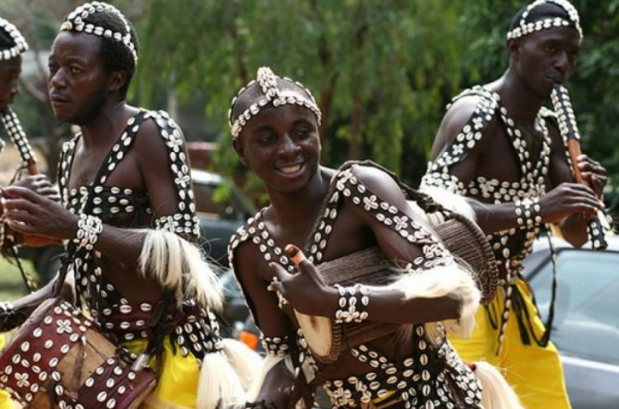

While they do not hate modern population as much as the Sentinelese, they are still rooted in their tribal customs and traditions. Unfortunately, the building of the Great Andaman Trunk Road has resulted in a lot of exploitation of the tribes by tourists and modern local societies. The Jarawas are pretty weird when it comes to food though. They relish fish, pigs and other animals but wouldn't touch a deer, which the area is highly populated with. Perhaps they consider deer sacred. Also, the tribal people of Jarawa change the names of their children post puberty. There is an elaborate ceremony held to celebrate, in which a boy has to hunt a wild pig and offer it to everyone in the village, and a girl is anointed in clay, pig oil and gum, post which the children are given their new names. The tribals are also aware of contraceptive policies and use herbs and plants as contraceptives!

UPTO HERE - SOURCES:- <https://www.storypick.com/tribes-in-india/>

[https://www.indiatimes.com/culture/who-we-are/7-weird-indian-tribal-traditions-thatll-make-you-go-wtf-232282.htmlhttps://www.indiatimes.com/culture/who-we-are/7-weird-indian-tribal-traditions-thatll-make-you-go-wtf-232282.html](https://www.indiatimes.com/culture/who-we-are/7-weird-indian-tribal-traditions-thatll-make-you-go-wtf-232282.html)

The **Jarawas** (also Järawa, Jarwa) ([Jarawa](https://en.wikipedia.org/wiki/Jarawa_language_(Andaman_Islands)" \o "Jarawa language (Andaman Islands)): *Aong*, pronounced [[əŋ]](https://en.wikipedia.org/wiki/Help:IPA)[[2]](https://en.wikipedia.org/wiki/Jarawas_(Andaman_Islands)#cite_note-2)) are an [indigenous people](https://en.wikipedia.org/wiki/Andamanese_peoples) of the [Andaman Islands](https://en.wikipedia.org/wiki/Andaman_Islands) in India. They live in parts of [South Andaman](https://en.wikipedia.org/wiki/South_Andaman_Island) and [Middle Andaman](https://en.wikipedia.org/wiki/Middle_Andaman_Island) Islands, and their present numbers are estimated at between 250–400 individuals. They have largely shunned interaction with outsiders, and many particulars of their society, culture and traditions are poorly understood. Since the 1990s, contacts between Jarawa groups and outsiders grew increasingly frequent. By the 2000s, some Jarawas had become regular visitors at settlements, where they trade, interact with tourists, get medical aid, and even send their children to school.

The Jarawas are recognised as an [Adivasi](https://en.wikipedia.org/wiki/Adivasi" \o "Adivasi) group in India. Along with other indigenous [Andamanese](https://en.wikipedia.org/wiki/Andamanese" \o "Andamanese) peoples, they have inhabited the islands for several thousand years. The Andaman Islands have been known to outsiders since [antiquity](https://en.wikipedia.org/wiki/Ancient_history); however, until quite recent times they were infrequently visited, and such contacts were predominantly sporadic and temporary. For the greater portion of their history their only significant contact has been with other Andamanese groups. Through many decades, contact with the tribe has diminished quite significantly.

There is some indication that the Jarawa regarded the now-extinct [Jangil](https://en.wikipedia.org/wiki/Jangil" \o "Jangil) tribe as a parent tribe from which they split centuries or millennia ago, even though the Jarawa outnumbered (and eventually out-survived) the Jangil.[[3]](https://en.wikipedia.org/wiki/Jarawas_(Andaman_Islands)#cite_note-portman1898-3) The Jangil (also called the *Rutland Island Aka Bea*) were presumed extinct by 1931.[[4]](https://en.wikipedia.org/wiki/Jarawas_(Andaman_Islands)#cite_note-vanDriem2001-4)

## Origin[[edit](https://en.wikipedia.org/w/index.php?title=Jarawas_(Andaman_Islands)&action=edit&section=1" \o "Edit section: Origin)]

The Jarawas have been around for a long time. They are believed to be descendants of the Jangil tribe and it is estimated that they have been in the Andaman Islands for over two millennia. The Jarawas were both linguistically and culturally distinguished from the Greater Andamanese, who did not survive over the years. The early colonisations by the Jarawas showed evidence that there was an early movement of humans through southern Asia and indicate that phenotypic similarities with African groups are convergent. They are also believed to be the first successful tribe to move out of Africa. Any form of evidence on the Jarawas—social, cultural, historical, archaeological, linguistic, phenotypic, and genetic—support the conclusion that the Andaman Islanders have been isolated for a substantial period of time, which suggests why they have been able to survive despite modernization.[[6]](https://en.wikipedia.org/wiki/Jarawas_(Andaman_Islands)#cite_note-:0-6)

The Jarawas are one of the three surviving tribes in the area, the other two being Sentinelese and Onge. This triad is connected with the Greater Andamanese language clade on a typological—rather than a cognatic—basis, suggesting a historical separation of considerable depth.[[6]](https://en.wikipedia.org/wiki/Jarawas_(Andaman_Islands)#cite_note-:0-6)

### Hunting and diet[[edit](https://en.wikipedia.org/w/index.php?title=Jarawas_(Andaman_Islands)&action=edit&section=3" \o "Edit section: Hunting and diet)]

As the Jarawas are a nomadic tribe; they hunt endemic wild pigs, [monitor lizards](https://en.wikipedia.org/wiki/Monitor_lizard) and other quarry with bows and arrows. They have recently begun keeping dogs to help with hunting, as the Onges and Andamanese do.[[7]](https://en.wikipedia.org/wiki/Jarawas_(Andaman_Islands)#cite_note-jstor1-7)

Since this is an island tribe, food sources in the ocean are highly important to them. Men fish with bows and arrows in shallow water. Women catch fish with baskets.

[Mollusks](https://en.wikipedia.org/wiki/Mollusca), [dugongs](https://en.wikipedia.org/wiki/Dugong) and turtles are a major part of the Jarawa diet. Besides meat and seafood, Jarawas collect fruit, tubers and honey from the forest. In order to get honey from bees, they use a plant extract to calm the bees.

The Jarawa bow, made of chuiood ([Sageraea](https://en.wikipedia.org/wiki/Sageraea" \o "Sageraea) elliptica), is known as "aao" in their own language. The arrow is called "patho". The wooden head of the arrow is made of [Areca](https://en.wikipedia.org/wiki/Areca) wood. To make the iron head arrow, called "aetaho" in their language, they use iron and Areca wood or bamboo. When they go hunting or on raids, they wear a chest guard called "kekad".[[16]](https://en.wikipedia.org/wiki/Jarawas_(Andaman_Islands)#cite_note-16)

Food preparation is mainly done by roasting; baking as well as boiling. However, the Jarawas also consume food raw. The Jarawas have well balanced diets, and since they exploit both terrestrial as well as aquatic resources, they can easy supplement one type of food by another one in case of a shortage.[[17]](https://en.wikipedia.org/wiki/Jarawas_(Andaman_Islands)#cite_note-17)

The Jarawas also have support from the Indian government. They receive monthly allowances by the government and also receive wages for taking care of citrus fruit plantations. The Jarawas have a strong dependence on gathering different items, such as turtle eggs, honey, yams, larvae, jackfruit and wild citrus fruits and wild berries.

## Impact of the Great Andaman Trunk Road[[edit](https://en.wikipedia.org/w/index.php?title=Jarawas_(Andaman_Islands)&action=edit&section=4" \o "Edit section: Impact of the Great Andaman Trunk Road)]

The biggest threat to the Jarawa in recent years came from the building of the [Great Andaman Trunk Road](https://en.wikipedia.org/wiki/Great_Andaman_Trunk_Road) through their newer western forest homeland in the 1970s.[[11]](https://en.wikipedia.org/wiki/Jarawas_(Andaman_Islands)#cite_note-lota2006gs-11)[[12]](https://en.wikipedia.org/wiki/Jarawas_(Andaman_Islands)#cite_note-abbi2006-12) In late 1997, some Jarawa started coming out of their forest to visit nearby settlements for the first time. Within months a serious [measles](https://en.wikipedia.org/wiki/Measles) epidemic broke out.[*[citation needed](https://en.wikipedia.org/wiki/Wikipedia:Citation_needed" \o "Wikipedia:Citation needed)*] In 1999 and 2006 the Jarawa suffered another outbreak of measles.[[18]](https://en.wikipedia.org/wiki/Jarawas_(Andaman_Islands)#cite_note-18) No deaths were reported.

The impact of the highway, in addition to widespread encroachment, [poaching](https://en.wikipedia.org/wiki/Poaching) and commercial exploitation of Jarawa lands, caused a lawsuit to be filed with the [Calcutta High Court](https://en.wikipedia.org/wiki/Calcutta_High_Court), which has jurisdiction over the islands. The case escalated to the [Supreme Court of India](https://en.wikipedia.org/wiki/Supreme_Court_of_India) as a [Public Interest Litigation](https://en.wikipedia.org/wiki/Public_Interest_Litigation) (PIL). The [Society for Andaman and Nicobar Ecology](https://en.wikipedia.org/wiki/Society_for_Andaman_and_Nicobar_Ecology), the [Bombay Natural History Society](https://en.wikipedia.org/wiki/Bombay_Natural_History_Society) and [Pune](https://en.wikipedia.org/wiki/Pune" \o "Pune)-based [Kalpavriksh](https://en.wikipedia.org/wiki/Kalpavriksh" \o "Kalpavriksh) joined in the petition, resulting in a landmark High Court judgment in 2001, directing the administration to take steps to protect the Jarawa from encroachment and contact, as well as preemptively ruling out any program that involved relocating the Jarawa to a new reservation. Planned extensions of the highway were also prohibited by the court.[[19]](https://en.wikipedia.org/wiki/Jarawas_(Andaman_Islands)#cite_note-indiatogethersdj-19) However, the *Light of Andamans* editorialised that the changes to the Jarawa were likely irreversible and should have been assessed more thoroughly before the road was built.[[11]](https://en.wikipedia.org/wiki/Jarawas_(Andaman_Islands)#cite_note-lota2006gs-11)

UPTO HERE - <https://en.wikipedia.org/wiki/Jarawas_(Andaman_Islands)>

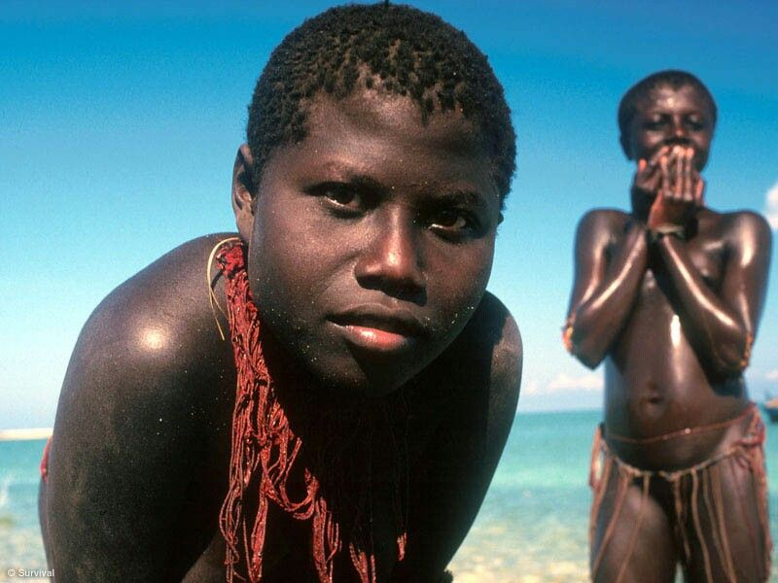

SRC = <https://i.pinimg.com/originals/93/87/d7/9387d782c97668faf5bcabc8f02fde7c.jpg>

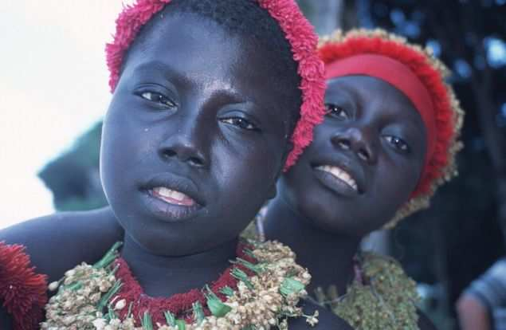

SRC = <https://timesofindia.indiatimes.com/photo/44926323.cms>

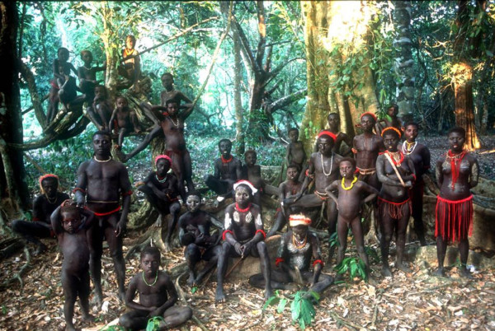

SRC = <https://i2.wp.com/indiathedestiny.com/wp-content/uploads/2016/03/jarawa-e1458012096519.jpg?resize=600%2C402>

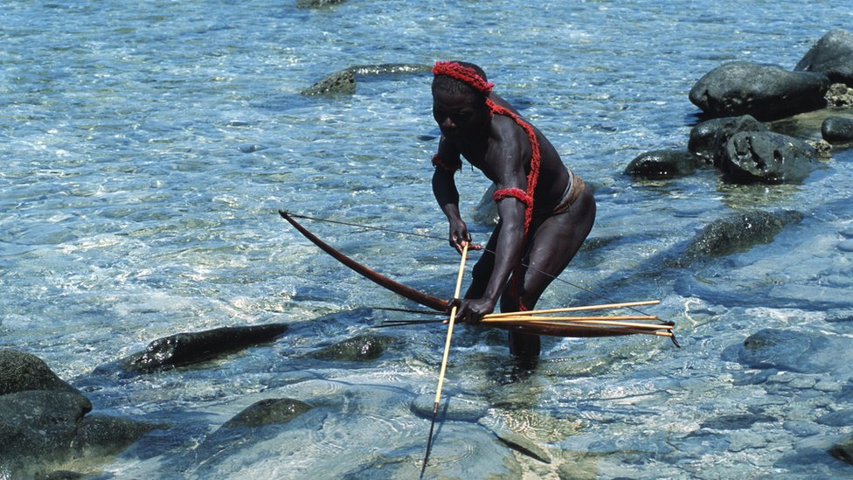

SRC = <https://c.files.bbci.co.uk/11CA1/production/_104456827_gettyimages-175095735-1.jpg>

# CHENCHUS , ANDHRA PRADESH:- w

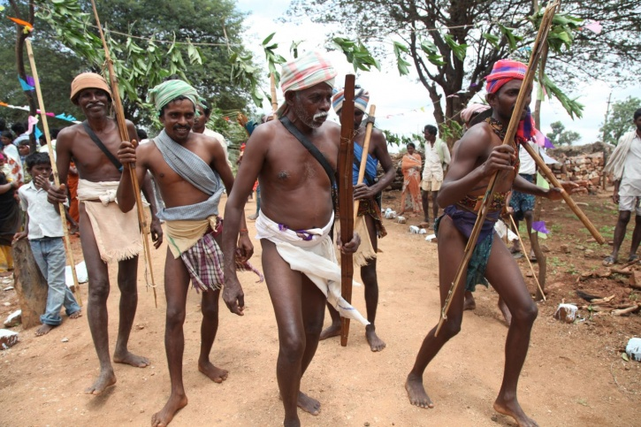

The Chenchus are a tribe residing mainly in Andhra Pradesh and speak a dialect of the Telugu language known as Chenchu. The Chenchus of Andhra Pradesh are quite forward in their thoughts, compared to the rest of Indian society, when it comes to matters of the heart. Chenchu youth are free to marry whoever they wish to. There is no form of parental pressure or aggression. Also, the clan is divided into Gotras (like our caste system), and generally they do not marry within the same Gotra. Unlike our rigid society, Chenchu tribes allow divorce, and widows too are allowed to remarry. Well, maybe our society can take a few 'lessons' from them?

UPTO HERE - SOURCES:- <https://www.storypick.com/tribes-in-india/>

[https://www.indiatimes.com/culture/who-we-are/7-weird-indian-tribal-traditions-thatll-make-you-go-wtf-232282.htmlhttps://www.indiatimes.com/culture/who-we-are/7-weird-indian-tribal-traditions-thatll-make-you-go-wtf-232282.html](https://www.indiatimes.com/culture/who-we-are/7-weird-indian-tribal-traditions-thatll-make-you-go-wtf-232282.html)

The **Chenchus** are [Adivasi](https://en.wikipedia.org/wiki/Adivasi" \o "Adivasi), a designated [Scheduled Tribe](https://en.wikipedia.org/wiki/Scheduled_Castes_and_Scheduled_Tribes) in the [Indian](https://en.wikipedia.org/wiki/India) states of [Andhra Pradesh](https://en.wikipedia.org/wiki/Andhra_Pradesh), [Telangana](https://en.wikipedia.org/wiki/Telangana" \o "Telangana), [Karnataka](https://en.wikipedia.org/wiki/Karnataka) and [Odisha](https://en.wikipedia.org/wiki/Odisha" \o "Odisha).[[1]](https://en.wikipedia.org/wiki/Chenchu_people#cite_note-1) They are an [aboriginal tribe](https://en.wikipedia.org/wiki/Adivasi) whose traditional way of life been based on [hunting and gathering](https://en.wikipedia.org/wiki/Hunter-gatherer). The Chenchus speak the [Chenchu language](https://en.wikipedia.org/wiki/Chenchu_language" \o "Chenchu language), a member of the [Dravidian](https://en.wikipedia.org/wiki/Dravidian_languages) language family. In general, the Chenchu relationship to non-tribal people has been largely symbiotic. Some Chenchus have continued to specialize in collecting forest products for sale to non-tribal people. Many Chenchus live in the dense [Nallamala forest](https://en.wikipedia.org/wiki/Nallamala_Forest" \o "Nallamala Forest) of Andhra Pradesh.

The Chenchus are referred to as one of the Primitive Tribal Groups that are still dependent on forests and do not cultivate land but hunt for a living. Non-tribe people living among them rent land from the Chenchus and pay a portion of the harvest. [Dalits](https://en.wikipedia.org/wiki/Dalit" \o "Dalit) also settled among them with the help of the Chenchus and learned agriculture from them, and the nomadic [Banjara](https://en.wikipedia.org/wiki/Banjara" \o "Banjara) herders who graze their cattle in the forest also have been allotted land there. The Chenchus have responded unenthusiastically to government efforts to induce them to take up agriculture themselves.

UPTO HERE - <https://en.wikipedia.org/wiki/Chenchu_people>

Chenchus are a Particularly Vulnerable Tribal Group whose hamlets or *Pentas* dot the Nallamala forest range spread across four to five districts in Telangana and Andhra Pradesh states. They are inveterate forest dwellers, who have, over centuries, steadfastly refused to move out of their woods regardless of the perils of such life. If patriotism be defined as love for the land, Chenchus are patriots in true spirit. The non-resident war cries on social media over imagined boundaries are no match for their raw affinity to forests where they live without basic facilities.

Love for life or prolonging of life, for one, is not the concern that bothers Chenchus ever. Baffling still, whenever the successive governments provided them agricultural lands in a bid to bring them out of forests, they died in higher numbers after losing the land to manipulative outsiders in return for hooch! They have no use for material wealth.

“They will live and die there. They will die even if they come out. So, we do not press them to go out,” says a forester, “For a Chenchu man who comes out on some work, entering the woods itself is coming home. His hamlet might be 30 kilometres farther, which he will walk slowly, resting occasionally, picking little forest treats, but he would have already let out a sigh, pleased with the idea of coming home.”

He also gives a peek into the uncanny shyness of Chenchus, whom a stranger may pester to no end with hundred questions, but extract no more than monosyllables.

“When this region was a Naxalite bastion, the revolutionaries would take shelter inside the hamlets. Chenchus would say no to neither — them or the police. Police would torture them endlessly, but silence is what they would be rewarded with.”

Well, it’s cacophony we need to sustain the “development” in our world, or to take the supposedly momentous, but dishonest decisions about reversing the damage done. But quiet and stillness is what the life in forests taught Chenchus, primarily a hunting, gathering tribe. After all, you don’t rustle about and give yourself away to either your prey or predator!

Mallikarjun, my host, was more articulate than the rest, owing to his association with city-based NGOs working for land and food rights. At 26, he was already married with two kids, and lived in a two-room house beside which he retained his bamboo-and-thatch hut typical of Chenchu *Pentas*. That night, after feeding me with *jowar rotis* and vegetable curry, he related to me the Chenchu way of life, and laid siege to my attention for hours. A tiny part of his narrative, I take the privilege to reproduce here.

Until Mallikarjun told, beehives, for me, were those dangling threats suspended from trees or rooftops, which we should steer clear of unless we wished to be stung to death.

There are many kinds, clarified Mallikarjun, and a method to take down each.

.

UPTP HERE = <https://www.thehindu.com/thread/arts-culture-society/article8024962.ece>

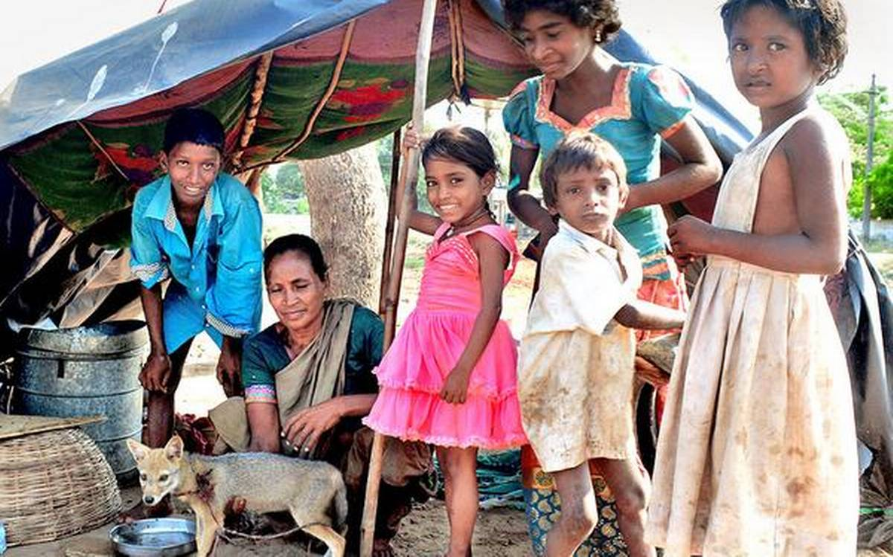

SRC = https://www.thehindu.com/news/cities/Vijayawada/iy1xc4/article28736721.ece/ALTERNATES/LANDSCAPE_1200/indianfamily<https://www.thehindu.com/news/cities/Vijayawada/iy1xc4/article28736721.ece/ALTERNATES/LANDSCAPE_1200/indianfamily>

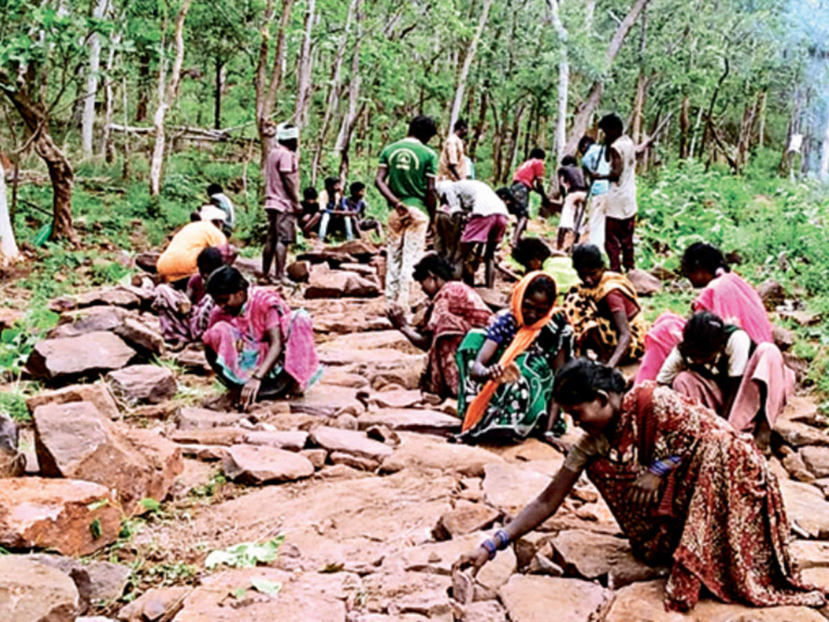

SRC = <https://timesofindia.indiatimes.com/thumb/msid-77842648,width-1200,height-900,resizemode-4/.jpg>

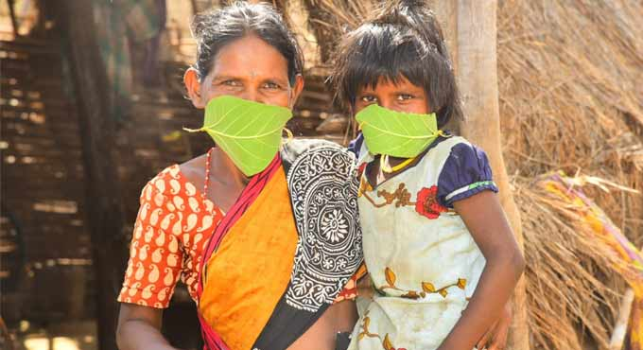

SRC = <https://cdn.telanganatoday.com/wp-content/uploads/2020/05/Chenchus.jpg>

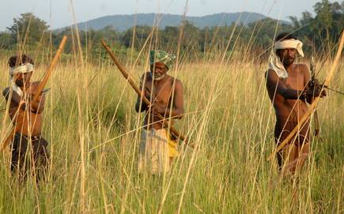

SRC = <https://th.thgim.com/migration_catalog/article10021473.ece/alternates/LANDSCAPE_435/ChenchuTitle>

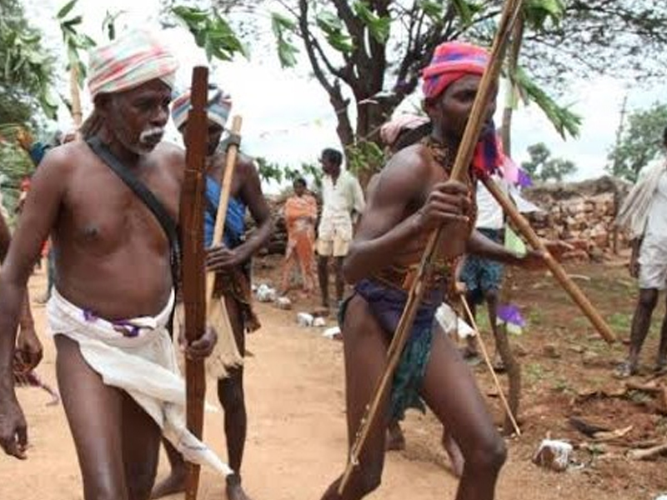

SRC = <https://static.toiimg.com/img/71031838/Master.jpg>

# KHASI TRIBE , MEGHALYA:- w

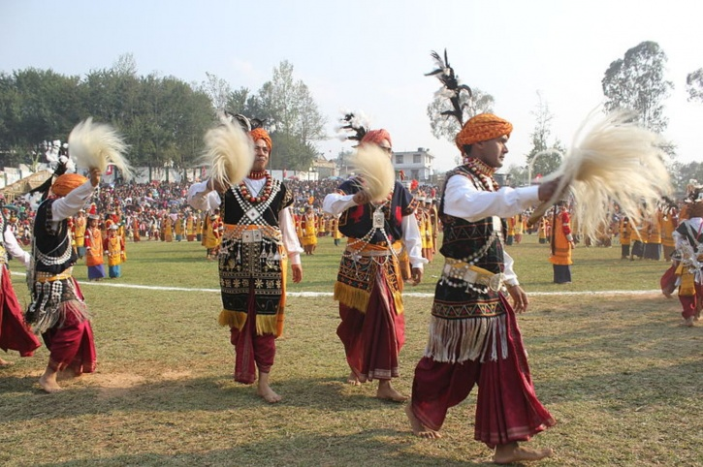

The Khasi tribe is a pretty peace loving tribe and they are named after the language they speak: Khasi language. While most of the Khasis follow their tribal religion, there are many converts who have taken up other religions like Christianity and Islam. One thing that makes the tribe unique is that they are a matrilineal tribe, which means they carry on the maternal tradition. The children's surnames are based on the mother's lineage and not the fathers. Also, it is the mother who inherits the property and not the father. Also, Khasi tribals do not prefer arranged marriages. In case of a divorce, the woman has complete freedom. Her choice cannot be questioned and she owns the children and properties. The property post death/conflicted property always goes to the youngest daughter. Women, thinking of converting to the Khasi tradition?

Another cool thing about them is their divorce method. While the younger generation does resort to courts, most of the Khasis follow the traditional method. The husband hands the wife 5 paise which the wife returns after adding 5 of her own. The coins are then given to the village elder who throws them away. And done! Divorce complete!

UPTO HERE - SOURCES:- <https://www.storypick.com/tribes-in-india/>

[https://www.indiatimes.com/culture/who-we-are/7-weird-indian-tribal-traditions-thatll-make-you-go-wtf-232282.htmlhttps://www.indiatimes.com/culture/who-we-are/7-weird-indian-tribal-traditions-thatll-make-you-go-wtf-232282.html](https://www.indiatimes.com/culture/who-we-are/7-weird-indian-tribal-traditions-thatll-make-you-go-wtf-232282.html)

The **Khasi people** are an indigenous ethnic group of [Meghalaya](https://en.wikipedia.org/wiki/Meghalaya) in north-eastern [India](https://en.wikipedia.org/wiki/India) with a significant population in the bordering state of [Assam](https://en.wikipedia.org/wiki/Assam), and in certain parts of [Bangladesh](https://en.wikipedia.org/wiki/Bangladesh). The Khasi people form the majority of the population of the eastern part of [Meghalaya](https://en.wikipedia.org/wiki/Meghalaya), and is the state's largest community, with around 48% of the population of Meghalaya. They are the only [Mon-Khmer](https://en.wikipedia.org/wiki/Austroasiatic) speaking people in [South Asia](https://en.wikipedia.org/wiki/South_Asia). A cultural tradition of the Khasi people is that they follow the matrilineal system of descent and inheritance. Under the Constitution of India, the Khasis have been granted the status of [Scheduled Tribe](https://en.wikipedia.org/wiki/Scheduled_Castes_and_Scheduled_Tribes).

### Khasi mythology[[edit](https://en.wikipedia.org/w/index.php?title=Khasi_people&action=edit&section=2" \o "Edit section: Khasi mythology)]

Khasi mythology traces the tribe's original abode to '*Ki Hynñiewtrep* ("The Seven Huts").[[2]](https://en.wikipedia.org/wiki/Khasi_people#cite_note-Banaji2010-2) According to the Khasi mythology, *U Blei Trai Kynrad* (God, the Lord Master) had originally distributed the human race into 16 heavenly families (*Khadhynriew Trep*).[[3]](https://en.wikipedia.org/wiki/Khasi_people#cite_note-Nongkinrih2002-3) However, seven out of these 16 families were stuck on earth while the other 9 are stuck in heaven. According to the myth, a heavenly ladder resting on the sacred Lum Sohpetbneng Peak (located in the present-day [Ri-Bhoi district](https://en.wikipedia.org/wiki/Ri-Bhoi_district" \o "Ri-Bhoi district)) enabled people to go freely and frequently to heaven whenever they pleased until one day they were tricked into cutting a divine tree which was situated at Lum Diengiei Peak (also in present-day Ri-Bhoi district), a grave error which prevented them access to the heavens forever. This myth is often seen[[*by whom?*](https://en.wikipedia.org/wiki/Wikipedia:Manual_of_Style/Words_to_watch#Unsupported_attributions)] as a metaphor of how nature and trees, in particular, are the manifestation of the divine on Earth and destroying nature and trees means severing our ties with the Divine. Like the Japanese, the Khasis use the rooster as a symbol because they believe that it was he who aroused God and also humbly paved and cleared the path for God to create the Universe at the beginning of time. The rooster is the symbol of morning marking a new beginning and a new sunrise.

### Language[[edit](https://en.wikipedia.org/w/index.php?title=Khasi_people&action=edit&section=3" \o "Edit section: Language)]

*See also:*[*Peopling of India*](https://en.wikipedia.org/wiki/Peopling_of_India)

The [Khasi language](https://en.wikipedia.org/wiki/Khasi_language" \o "Khasi language) is classified as part of the [Austroasiatic](https://en.wikipedia.org/wiki/Austroasiatic" \o "Austroasiatic) language family. According to [Peter Wilhelm Schmidt](https://en.wikipedia.org/wiki/Wilhelm_Schmidt_(linguist)) , the Khasi people are related to the [Mon-Khmer](https://en.wikipedia.org/wiki/Mon%E2%80%93Khmer_languages) people of South East Asia. Multiple types of research indicate that the Austroasiatic populations in India are derived from migrations from Southeast Asia during the [Holocene](https://en.wikipedia.org/wiki/Holocene) period. Many of the words are similar to other Austroasiatic languages such as [Palaung](https://en.wikipedia.org/wiki/Palaung_language) and [Khmer language](https://en.wikipedia.org/wiki/Khmer_language):

* Tiger- Khla (Both Khasi &Khmer).
* To fly- Her in [Khasi], haer in [Khmer]
* Belly- kpoh in [khasi], poh in [khmer], bung in Vietnamese.
* New-  'Thymme or thymmai' in Khasi , thmei or thmai in [Khmer], moi in Vietnamese
* Year- Snem in [Khasi] , chnem in [khmer], nam in Vietnamese
* Far- jngai in [Khasi], chngay in [Khmer]
* Leaf- Sla or 'la in [khasi] , slaek in [khmer], la in [Vietnamese language]
* Crab- tham in [khasi] , ktam in[khmer]
* Fingers- preamti in[only [pnar dialect](https://en.wikipedia.org/wiki/Pnar_language" \o "Pnar language) (khasi sub-tribe)] , mreamdai in[khmer ], ngon tay in Vietnamese.
* Toes- preamjat in [only  [pnar dialect](https://en.wikipedia.org/wiki/Pnar_language" \o "Pnar language) (khasi sub-tribe)],mreamcheung in [khmer], ngon chan in Vietnamese.
* Children- Khun,khon,kon in [khasi], kaun, kon, in [khmer], con in [vietnamese]
* Birds- sim in {khasi}, 'chim in {vietnamese}
* Eyes- khmat or 'mat in {khasi}, mat in {vietnamese}
* Fish- 'kha in [Khasi] , 'Ca' in [Vietnamese]
* Mother - mei in [khasi] , mẹ in [vietnamese], mea also in [Thai a [kra](https://en.wikipedia.org/wiki/Kra%E2%80%93Dai_languages" \o "Kra–Dai languages)-dai language family]
* Lion- 'sing'  in [Khasi] , singto in [Thai a [kra](https://en.wikipedia.org/wiki/Kra%E2%80%93Dai_languages" \o "Kra–Dai languages)-dai language family]
* Rice- Khaw in [Khasi] and [Thai](https://en.wikipedia.org/wiki/Thai_language) also 'Khaw', Gao in Vietnamese.

There are also similar to those in [Sino-Tibetan languages](https://en.wikipedia.org/wiki/Sino-Tibetan_languages), such as *nga* meaning "I," which is the same in Tibetan, Burmese, and [Old Chinese](https://en.wikipedia.org/wiki/Old_Chinese) as it is in Khasi. Traces of connections with the Kachin tribe of North Burma have also been in the Khasis. The Khasi people also have their own word for the Himalayan mountains which is "Ki Lum Mankashang" which means that at one point in time, they did cross the mighty mountains. Therefore, all these records and their present culture, features, and language strongly show that they also have a strong Tibeto-Himalayan- Burman influence. The word "Khas" means hills and they have always been people of cold and hilly regions and have never been connected to the plains or arid regions. This nature-loving tribe calls the wettest place on Earth their home. The village of Mawsynram in Meghalaya receives 467 inches of rain per year.

Primarily an oral language, they had no script of their own, they used the Bengali script until the arrival of the Welsh missionaries. Particularly significant in this regard was a Welsh evangelist, [Thomas Jones](https://en.wikipedia.org/wiki/Thomas_Jones_(missionary)), who had transcribed the Khasi language into the Roman Script.

## Dress[[edit](https://en.wikipedia.org/w/index.php?title=Khasi_people&action=edit&section=6" \o "Edit section: Dress)]

The traditional Khasi male dress is a *Jymphong*, a longish sleeveless coat without collar, fastened by thongs in front. Nowadays, most male Khasis have adopted western attire. On ceremonial occasions they appear in a *Jymphong* and [sarong](https://en.wikipedia.org/wiki/Sarong) with an ornamental waist-band and they may also wear a turban.

The traditional Khasi female dress is called the *Jainsem* or *Dhara*, both of which are rather elaborate with several pieces of cloth, giving the body a cylindrical shape. On ceremonial occasions, they may wear a crown of silver or gold. A spike or peak is fixed to the back of the crown, corresponding to the feathers worn by the menfolk. The *Jainsem* consists of two pieces of material fastened at each shoulder. The "Dhara" consists of a single piece of material also fastened at each shoulder.

## Marriage[[edit](https://en.wikipedia.org/w/index.php?title=Khasi_people&action=edit&section=7" \o "Edit section: Marriage)]

The Khasis are, for the most part, monogamous. Their social organisation does not favour other forms of marriage; therefore, deviation from this norm is quite rare. Young men and women are permitted considerable freedom in the choice of mates. Potential marriage partners are likely to have been acquainted before betrothal. Once a man has selected his desired spouse, he reports his choice to his parents. They then secure the services of a mediator to make the arrangements with the woman's family (provided that the man's clan agree with his choice). The parents of the woman ascertain her wishes and if she agrees to the arrangement her parents check to make certain that the man to be wed is not a member of their clan (since Khasi clans are exogamous, marital partners may not be from the same clan). If this is satisfactory then a wedding date is set.

Divorce (with causes ranging from incompatibility to lack of offspring) is easily obtainable. This ceremony traditionally consists of the husband handing the wife 5 cowries or paisa which the wife then hands back to her husband along with 5 of her own. The husband then throws these away or gives them to a village elder who throws them away. Present-day Khasis divorce through the Indian legal system.

The type of marriage is the determining factor in the marital residence. In short, post marital residence for a married man when an heiress (known as *Ka Khadduh*) is involved must be matrilocal (that is, in his mother-in-law's house), while post-marital residence when a non-heiress is involved is neolocal. Generally, Khasi men prefer to marry a non-heiress because it will allow them to form independent family units somewhat immune to pressures from the wife's kin. Traditionally (though nowadays rule is not absolutely true), a Khasi man returns to his Iing-Kur (maternal home) upon the death of his spouse (if she is a Khadduh and they both have no children). These practices are the result of rules governing inheritance and property ownership. These rules are themselves related to the structure of the Khasi Kur (clan system).

.'

## Traditional polities[[edit](https://en.wikipedia.org/w/index.php?title=Khasi_people&action=edit&section=9" \o "Edit section: Traditional polities)]

The traditional political structure of the Khasi community is democratic in nature. In the past, the Khasis consisted of independent native states called Syiemships, where male elders of various clans under the leadership of the Chief (called U Syiem) would congregate during Durbars or sessions and come to a decision regarding any dispute or problem that would arise in the Syiemship. At the village level, there exists a similar arrangement where all the residents of the village or town come together under the leadership of an elected Headman (called U Rangbah Shnong), to decide on matters pertaining to the locality. This system of village administration is much like the [Panchayati Raj](https://en.wikipedia.org/wiki/Panchayati_Raj" \o "Panchayati Raj) prevalent in most Indian States. There were around 25 independent native states on record which were annexed and acceded to the Indian Union. The Syiems of these native states (called Hima) were traditionally elected by the people or ruling clans of their respective domains. Famous among these Syiemships are Hima Mylliem, Hima Khyrim, Hima Nongkhlaw, amongst others. These Syiemships continue to exist and function till today under the purview of the Khasi Hills Autonomous District Council (KHADC), which draws its legal power and authority from the Sixth Schedule of the Constitution of India.[[4]](https://en.wikipedia.org/wiki/Khasi_people#cite_note-4)

## Religion[[edit](https://en.wikipedia.org/w/index.php?title=Khasi_people&action=edit&section=10)]

Before the arrival of Christian missionaries, the majority of the Khasi people practiced an indigenous tribal religion.[[5]](https://en.wikipedia.org/wiki/Khasi_people#cite_note-5)[[6]](https://en.wikipedia.org/wiki/Khasi_people#cite_note-6) Though around 85% of the Khasi populace have embraced Christianity, a substantial minority of the Khasi people still follow and practice their age old indigenous religion, which is known as *Ka Niam Khasi* or *Niam tre*. The main Christian denominations followed by the Khasis include [Catholicism](https://en.wikipedia.org/wiki/Catholic_Church), [Anglicanism](https://en.wikipedia.org/wiki/Anglicanism), [Presbyterianism](https://en.wikipedia.org/wiki/Presbyterianism) (largest Christian denomination among the Khasis), and others. There are also a small number of Khasis, as a result of inter-community marriages, who are Muslims. There are also followers of Khasi Unitarianism as founded by Hajom Kissor Sing Lyngdoh Nongbri

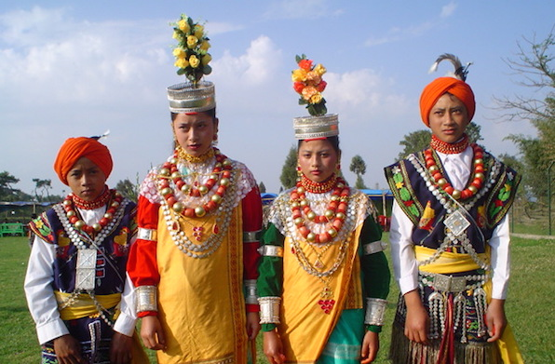

SRC = <https://www.shethepeople.tv/wp-content/uploads/2017/04/Khasi-tribe.jpg>

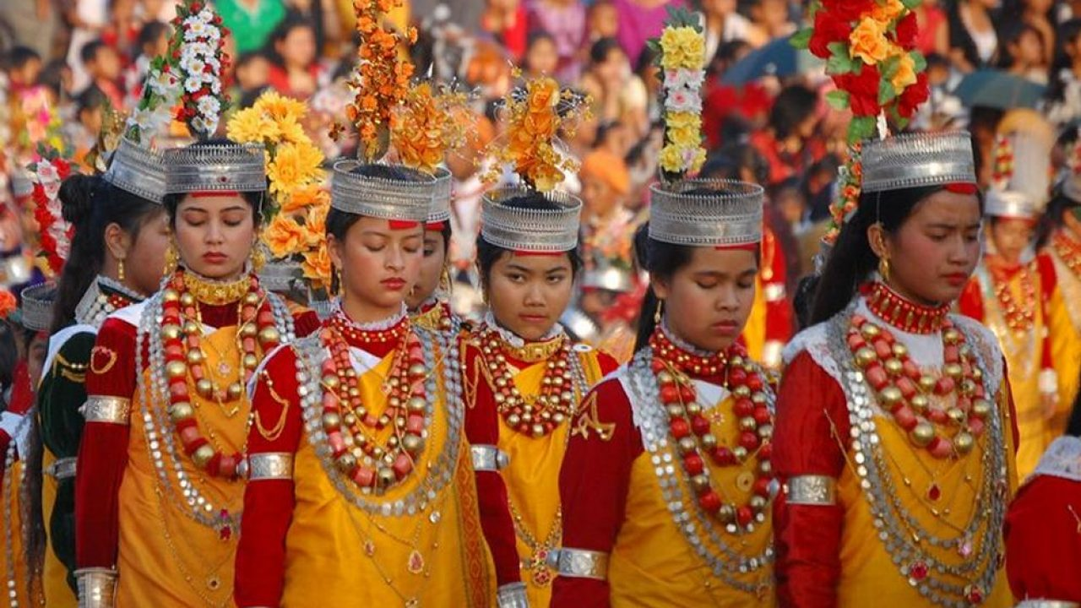

SRC = <https://www.topfivebuzz.com/wp-content/uploads/2017/04/khasi-tribe-of-India-1280x720.jpg>

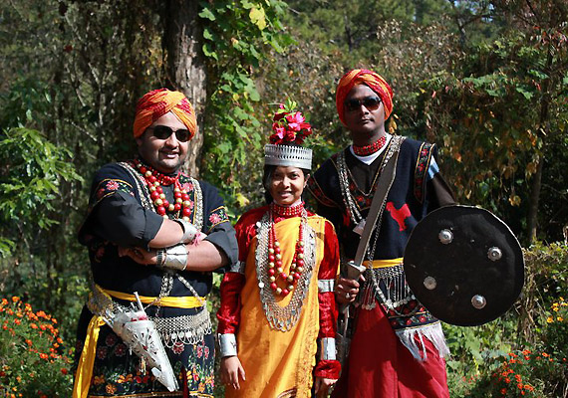

SRC = <https://resize.indiatvnews.com/en/resize/oldbucket/715_-/mainnational/In-Meghalaya-Kh29530.jpg>

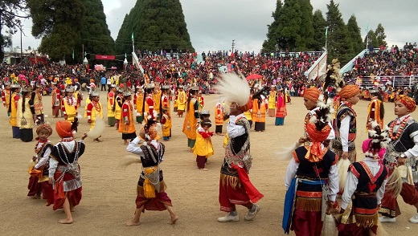

SRC = <https://www.swadesi.com/news/wp-content/uploads/2019/06/IMG-20181112-WA0043.jpg>